Exercise 2
- Write the SELECT statement to extract the ids of employees who are 30 years of age.
Answer: select emp_id from employee_data where age > 30;

- Write the SELECT statement to extract the first and last names of all web designer.
Answer: select f_name, l_name from employee_data where title = ‘ Web Designer’;

- What will the following SELECT statement display: SELECT * from employee_data where salary <= 100000;
Answer: 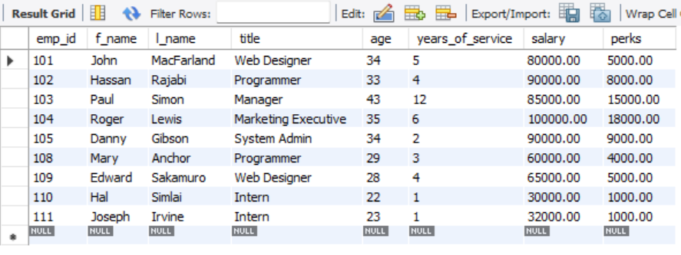

- How will you display the salaries and perks for employees who have more than $16000 as perks?
Answer: SELECT salary, perks FROM employee_data WHERE perks > 16000;

- List all employee names (last name followed by first name) who hold the title of Marketing Executive.
Answer: SELECT l_name, f_name FROM employee_data WHERE title = 'Marketing Executive';

